(Approx. 787 words)

The Best Things in Life are Free...Take 2
By Lou Torraca, President, The TUG-MOAA User Group, Hawaii
President@the-TUG.org
www.the-tug.org
Around Hawaii - Oceanic Time Warner Cable's Community Website
http://www.aroundhawaii.com/lifestyle/computers

Here is another list of “freebies” for u to use, beginning with a couple places u can find free movies and TV shows.

Although you'll need to sit through a few commercial breaks during the movies and shows at Crackle, an awesome selection of programming as well as decent video quality will have you coming back again and again. Although you'll need to sit through a few commercial breaks during the movies and shows at Crackle, an awesome selection of programming as well as a decent video quality makes it worthwhile.

Hulu is widely popular and there's a reason for it - it really is one of the best places out there to watch free movies online. You'll find hundreds of free movies online through their partnership with Miramax and movies from the Criterion Collection. These are free full length movies that you can watch over and over again without paying a dime and worrying whether you're breaking the law.

SnagFilms is also a favorite place to watch free movies online. It has a catalog of over 10,000 films that you can search by genre, newly added, most reviewed, and most popular.
Though they change often, one of their favorite features is the editor and user curated collections you'll find like "Best Time Travel," "Best Superhero," and "Scariest."

For occasions when you receive a questionable file that you fear might be loaded with malware, keep Jotti.org in your browser bookmarks. Upload a file to Jotti, and the site will scan it for badware using more than 20 security suites.

Google+ Hangouts
For video chat, Google+ Hangouts remains a cut above the competition. Unlike Skype, Google+ provides group video chat for free, and it also has some fun options such as the ability to watch a YouTube video together. Best of all, you needn’t be standing by to receive chat invitations; as long as your friends are still on the call, you can hop in at any time.
 |  | 
Wi-Fi Free Hotspot |  | Wi-Fi finder
In an effort to lure you inside, more restaurants and retailers are offering free Wi-Fi, including Starbucks, McDonald’s and Barnes & Noble. Some public libraries, campgrounds and hotels offer this freebie too. Go to WiFiFreeSpot.com to find places to surf when you’re away from home. Or download the Free Wi-Fi Finder app at iTunes.
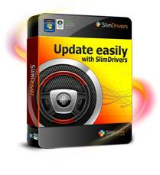 |  | 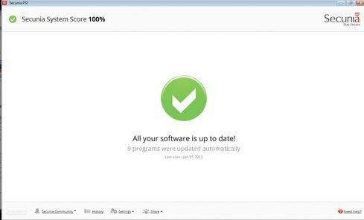
SlimDrivers |  | Secunia’s Personal Software Inspector
Two tools take some of the hassle out of general PC maintenance. SlimDrivers Free an app from SlimWare Utilities, runs in the background, detects when new hardware driver updates are available, and installs them automatically. Next, there’s Secunia’s Personal Software Inspector a security utility that scans your collection of third-party programs and automatically updates them, so you don’t have to worry about manually patching Adobe Reader the next time an emergency hotfix rolls out.
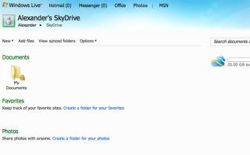 |  | 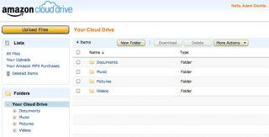 |  | 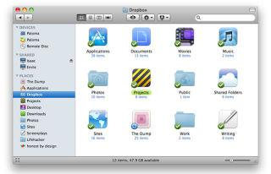
Windows Live OneDrive |  | Amazon Cloud Drive |  | Dropbox
With free online backup storage, you can share files and protect them from computer crashes, theft and natural disaster. Windows Live OneDrive gives you 25 gigabytes of free, secure digital storage space.
You can also use Amazon Cloud Drive (5 GB free) or Dropbox (2 GB free).
What's really great about all these products is that they're not identical and offer varying sets of features. It's not so much about which one's the best, but rather which one's the best for you. If you need to sync, go with Dropbox. If you want to pay absolutely nothing and get a ton of storage (25GB), go with Windows OneDrive. If you want reasonably-priced, tiered storage that's geared towards playing your music from anywhere, Amazon Cloud Drive is for you.

testPlus
Save money on your cell phone plan by using a free texting service such as textPlus. It assigns you a free phone number through which you can send and receive texts as much as you want on your Android devices, iPhone, iPad and iPod Touch.

To manage finances, check-out the free budgeting program at Mint.com.

If photographs are your focus, consider ThisLife, a service that lets you combine photos from multiple social networks—including Facebook, Flickr, Instagram, and Twitter—along with photos from your desktop. With your image files safely stored, you can search through them all at once and make edits. ThisLife is free for the first 1000 photos.
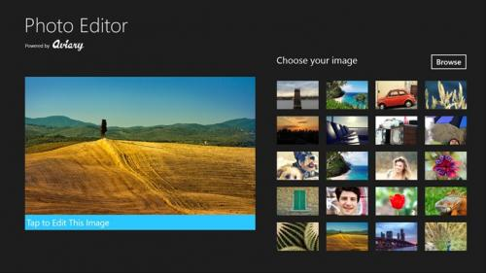 |  | 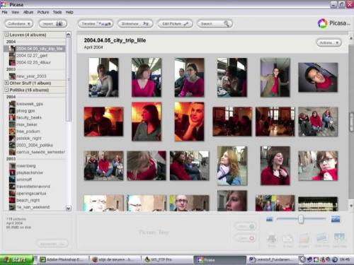 |  | 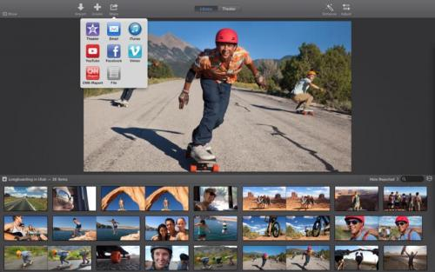
Aviary |  | Picasa |  | iMovie
And for photo and video editing, try Aviary, Picasa, Pixlr or Apple’s built-in iMovie software.
OK, that should keep u busy and… I hope happy, since the price is right, so have fun and keep safe out there…until the next time,
Aloha,
Lou

